http://{hostname}:{port}/api/Account/Register

Register new user

Return JSON stating the outcome of user registration

Postman testing shows that it does not pass Recaptcha test

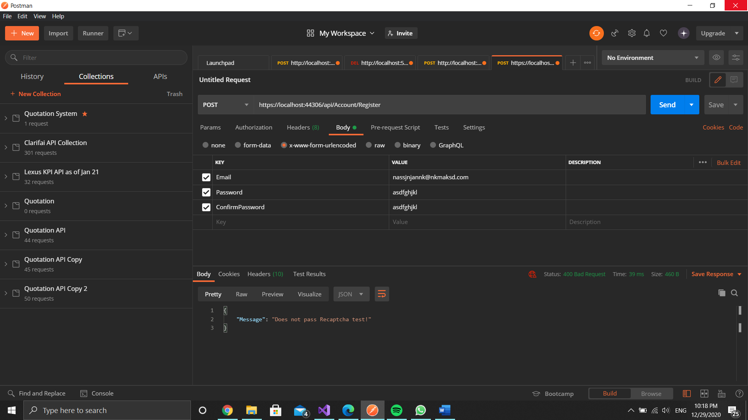

http://{hostname}:{port}/Token

Authenticate user and get access token

Return JSON contains access token, token type, token expiry date and username. 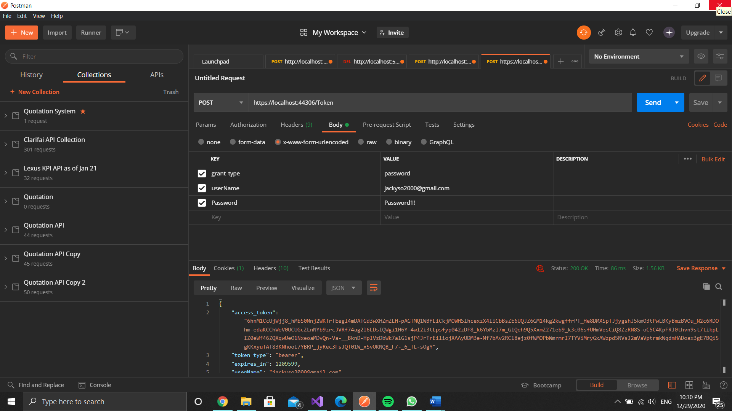

http://{hostname}:{port}/api/Account/Logout

Log user out from the system

Return status 200(OK)

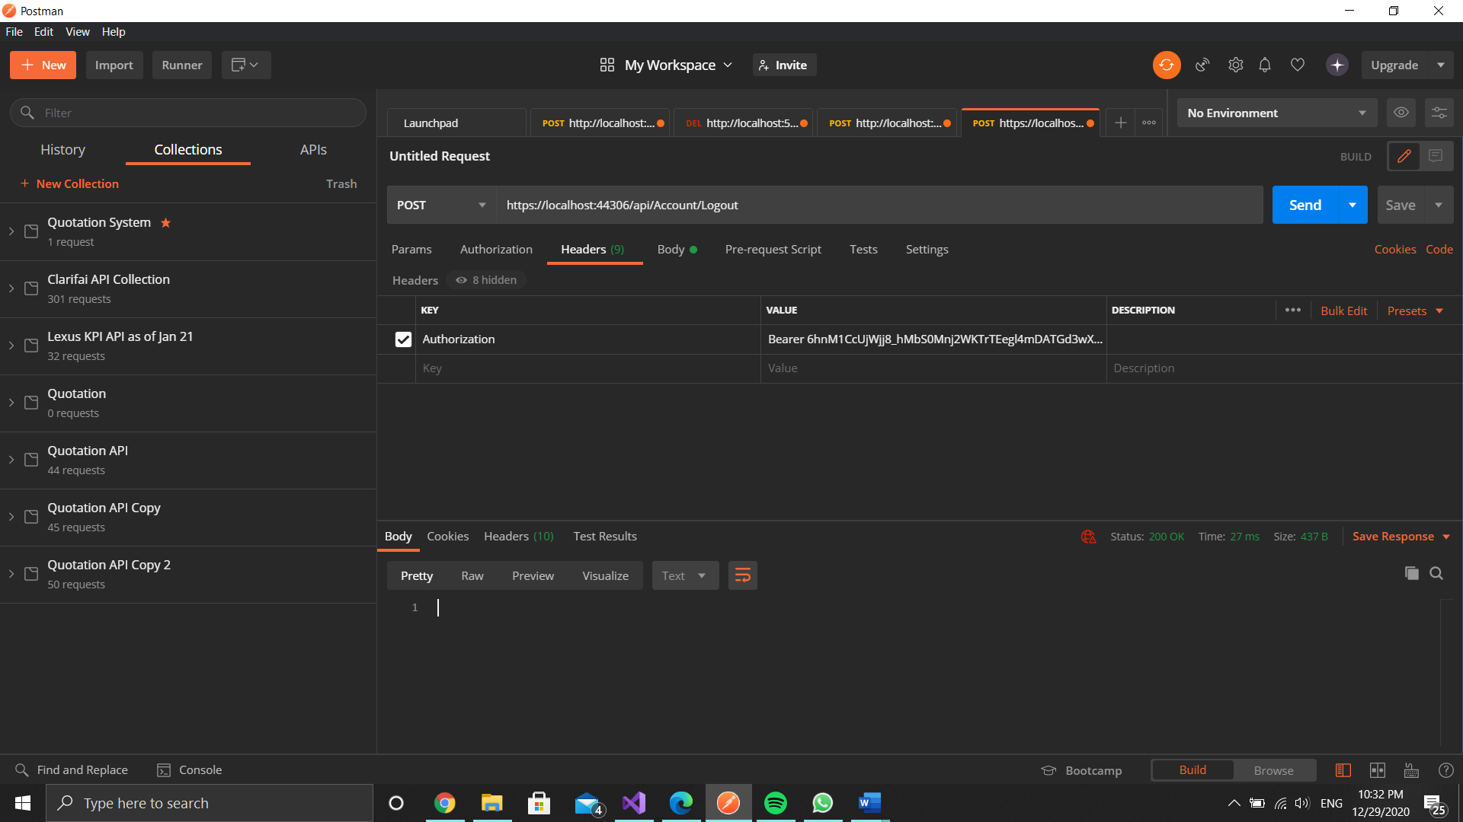

http://{hostname}:{port}/api/values

Get username

Return string contains of username

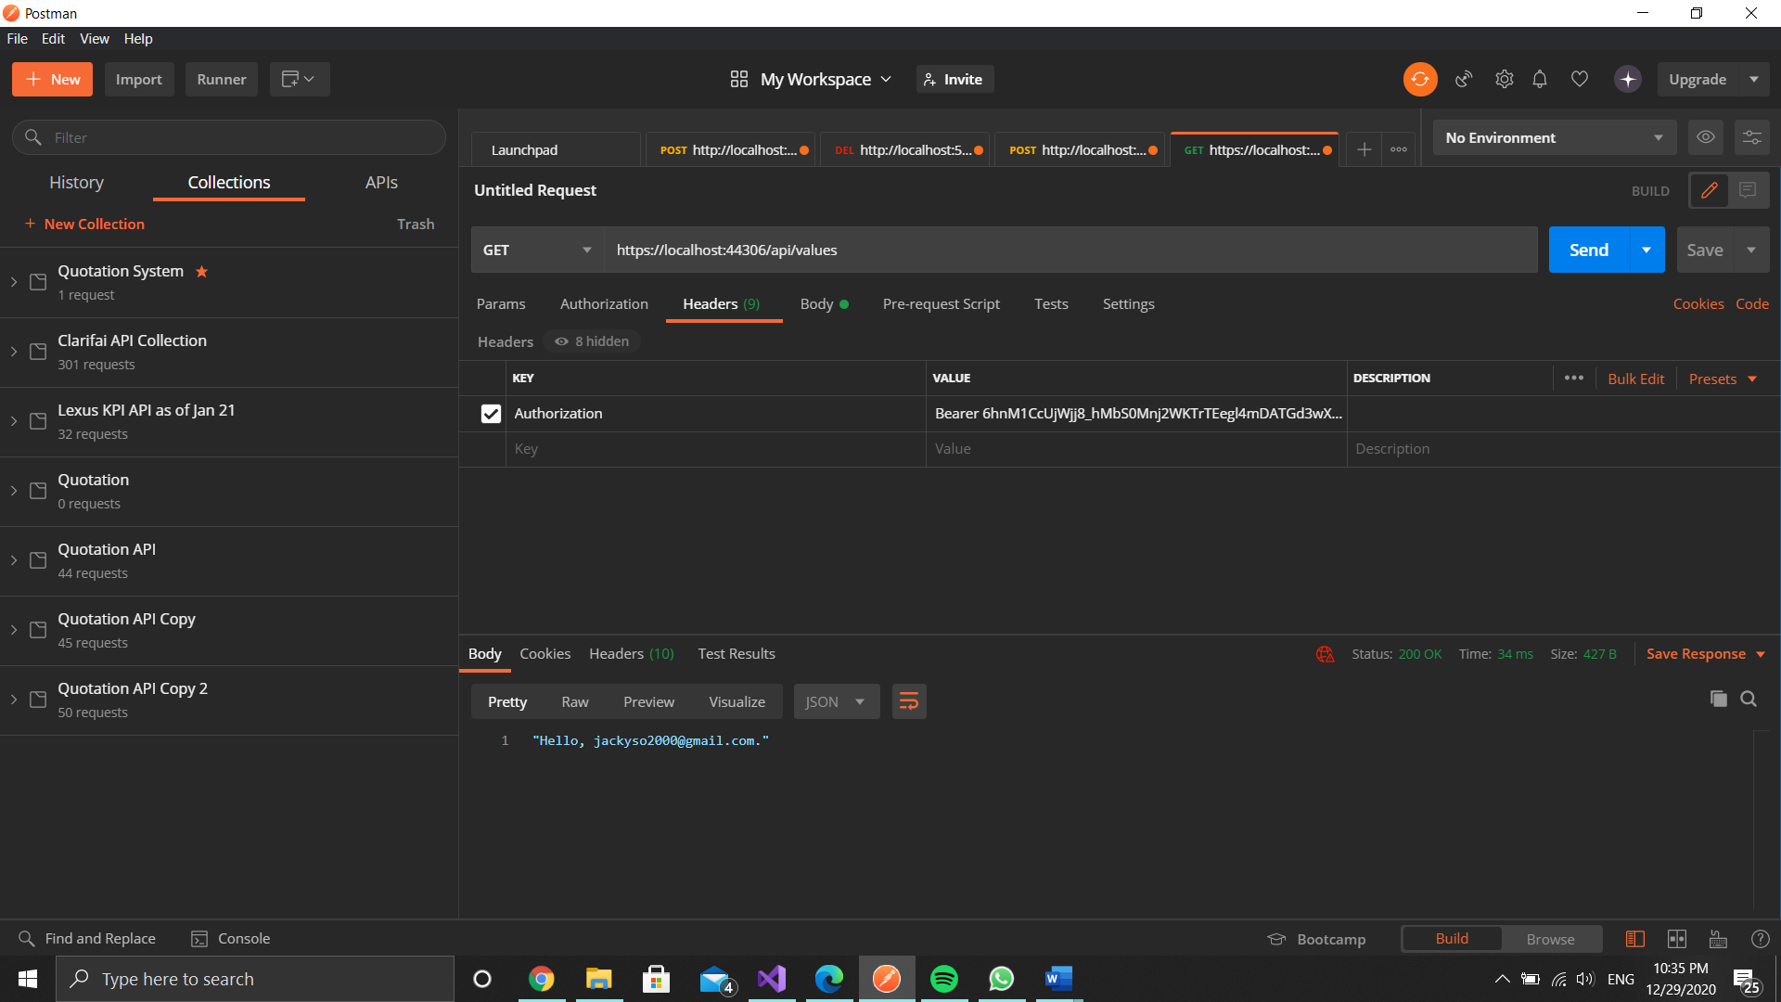

Sequence Diagram

